ISSUES IN VIETNAMESE TRANSLATION(STAGING)

1. Translation is wrong. Not matching with the term given in the excel sheet.

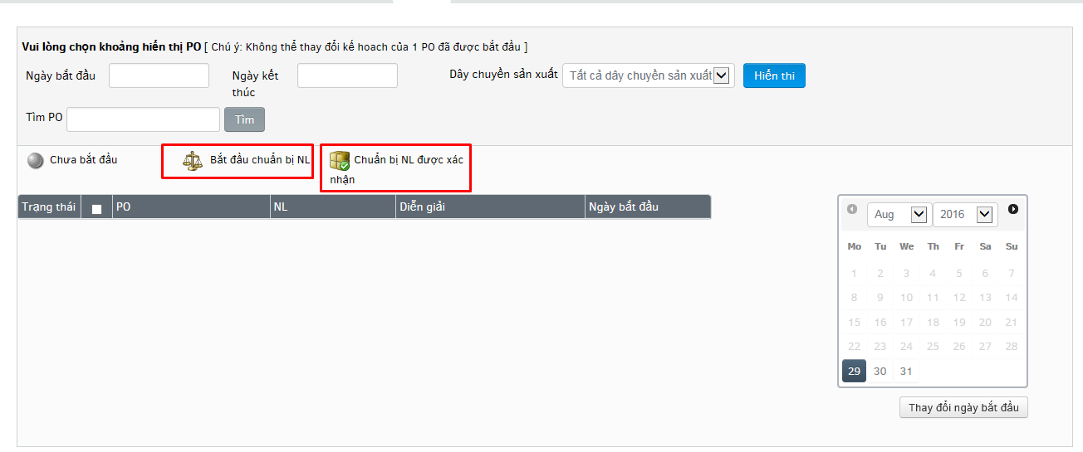

1. “Addition” is not translated.

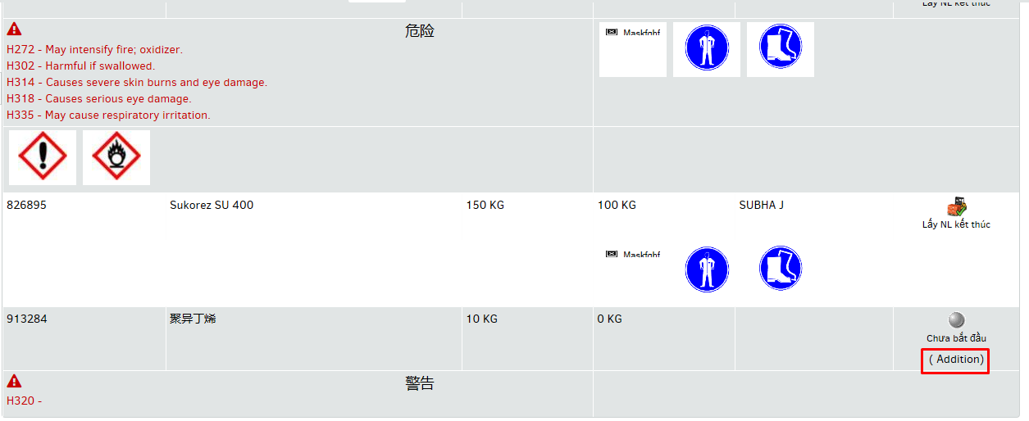

1. “finish date” and “Total quantity” are not translated but translations are present in excel

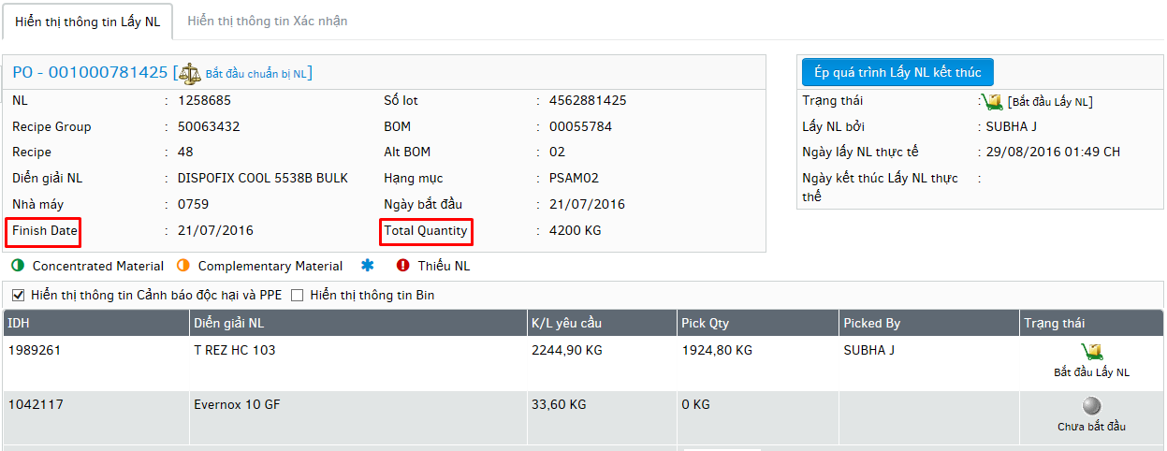

1. Only icon is present for pre-processing material no text is present.

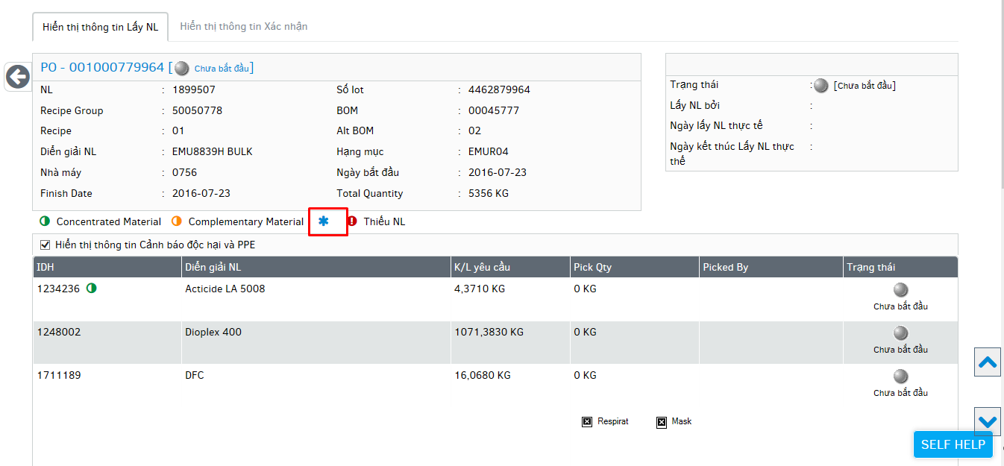

1. Translation for Saturday doesn’t match with given document.

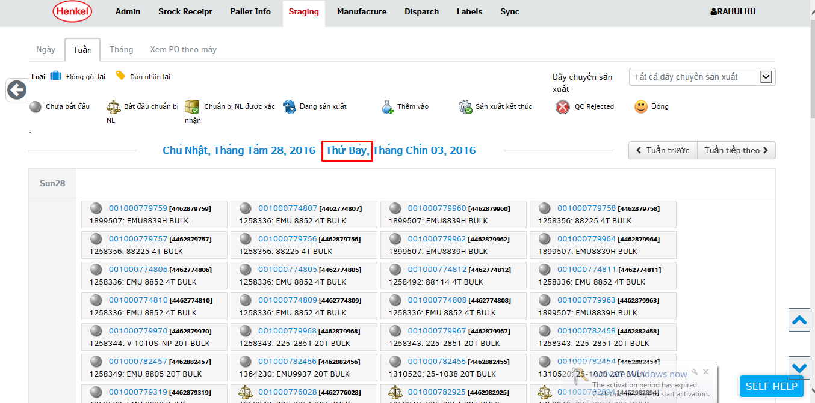

1. Day names are not translated in week view.

